**NeuraChat**

**Phase 2**

**Team 3**

**Course Instructor: Zeeshan Nazar**

|  |  |  |
| --- | --- | --- |
| **Team Members** | **Roll Number** | **Primary Responsibility** |
| Qatada Aadil | 23L-0998 | Use Cases 1-4 |
| Muhammad Ezaan | 23L-0676 | Use Cases 5-8 |
| Saad Zafar | 23L-0829 | Use Cases 9-12 |
| Anees Hamid | 23L-0671 | Use Cases 13-15 + EERD |

**National University of Computer and Emerging Sciences**

Department of Computer Science

Lahore, Pakistan

# **Table of Contents:**

Project Proposal ………………………………………………………………………………………………… 3

Use Case Diagram ……………………………………………………………………………………………… 8

Design Class Diagram ………………………………………………………………………………………… 9

Use Cases 1-15 (Swimlane+Sequence+State)…………………………………………………………. 10

EERD………………………………………………………………………………………………………………….71

# **Project Proposal**

**Abstract**

This project proposes the development of a modern real-time messaging application inspired by WhatsApp but enhanced with advanced artificial intelligence (AI) features and offline communication capabilities. Unlike traditional messaging platforms, our application integrates an AI-based real-time text summarizer and grammar corrector that will assist users in writing clear, concise, and professional messages. Additionally, incoming messages will be automatically summarized to provide users with quick insights without the need to read lengthy texts. A dedicated AI agent chat section will also be included, enabling users to interact with an AI assistant for various tasks such as information retrieval, writing help, and productivity support.

Moreover, the system will integrate a real-time audio and video calling feature powered by WebRTC, enhancing user communication beyond text messaging. The frontend will be developed using **Next.js** for a fast, responsive, and scalable user interface, while the backend will be built with **Node.js** to support real-time communication using WebSockets.The database layer will be powered by **Supabase**, providing scalable, secure, and real-time Postgres-backed storage with built-in authentication. This combination ensures both performance and extensibility. Overall, this project not only reimagines instant messaging but also integrates intelligent communication support and offline resilience, making it a next-generation communication platform.

**1. Introduction**

Instant messaging has become a cornerstone of modern communication, with platforms like WhatsApp, Telegram, and Signal connecting billions of users worldwide. These applications primarily focus on speed, security, and usability, offering features such as text messaging, multimedia sharing, voice/video calls, and group chats. However, despite their widespread adoption, current platforms lack **deep AI integration** for enhancing text communication, as well as **robust offline communication solutions** for areas with poor or no internet connectivity.

This project aims to address these gaps by designing and implementing a next-generation chat application that integrates **real-time AI features** such as message summarization, grammar correction, and intelligent suggestions. Furthermore, to enhance communication capabilities, the application will integrate WebRTC-based voice and video calling features, enabling richer real-time interactions. To ensure scalability and real-time data handling, Supabase will be used as the primary database and authentication service, complementing the Next.js frontend and Node.js backend.

**2. Goals and Objectives**

The primary objectives of this project are as follows:

* To design and implement a real-time chat application with a modern and intuitive user interface using **Next.js**.
* To develop a robust backend with **Node.js and WebSockets** to handle real-time messaging and user interactions.
* To leverage **Supabase** for secure user authentication, real-time database synchronization, and scalable cloud storage.
* To integrate an **AI-based grammar correction system** that improves outgoing messages.
* To employ **NLP** tools to enhance the clarity of a message and to aid in writing long and detailed messages based on user information.
* To secure communication powered by the Signal Protocol, ensuring **end-to-end encryption** with forward secrecy and post-compromise security.
* To incorporate an **AI-driven text summarizer** that condenses long incoming messages into short, readable summaries.
* To create a dedicated **AI agent chat interface** where users can interact with a built-in AI assistant for productivity tasks.
* "To implement real-time **voice or video calling** using **WebRTC**, integrated seamlessly with the chat system.
* To ensure scalability, security, and efficiency in handling multiple concurrent users.
* To document the design process using **UML diagrams (Use Case, Sequence, Activity, Class Diagrams)** and apply **relevant software design patterns**.

**3. Scope of the Project**

The scope of this project includes the design and development of a **real-time messaging platform enhanced with AI features**. The application will provide basic features such as user authentication, real-time text messaging, and multimedia sharing, along with advanced functionalities including AI-based text summarization, grammar correction, and an AI agent for user assistance. The project will use Supabase as the backend-as-a-service platform to handle authentication, real-time messaging synchronization, and structured database storage

Additionally, the project will support **real-time voice or video calling using WebRTC**, extending the communication experience beyond text and multimedia messages.

**Limitations of the Project:**

* The WebRTC-based calling feature may be limited by network quality, leading to potential latency or **dropped calls in low-bandwidth** environments.
* AI summarization and grammar correction will depend on pre-trained models, and **accuracy may vary** based on language complexity.

**4. Initial Study and Work Done so Far**

Research into existing messaging applications reveals several strengths and limitations. Platforms like WhatsApp and Signal excel in providing **real-time communication, encryption, and multimedia support**, but they lack **deep AI integration** for improving message quality or extracting insights from long conversations. Similarly, applications such as Telegram allow bots and third-party integrations but do not provide **native AI-based grammar correction or summarization**.

Previous research into AI-driven text summarization and grammar correction has shown promising results using transformer-based models such as **BERT, GPT, and T5**. These models are capable of producing coherent summaries and correcting grammatical errors with high accuracy. However, most existing work applies these models in document processing or writing assistance tools (e.g., Grammarly, Quillbot), not in **real-time messaging applications**. This presents a research gap where AI can be integrated into everyday communication to improve clarity, efficiency, and productivity.

Real-time communication technologies such as **WebRTC** are widely adopted for peer-to-peer audio and video calling. By leveraging WebRTC, our system aims to integrate calling features directly into the chat experience, unlike traditional messaging apps that separate calling and messaging modules.

**Importance of the Problem Statement:**

* Current messaging apps do not optimize text communication with AI (summarization, correction).
* Users in low-connectivity areas are left without communication options when internet access fails.
* Productivity-oriented AI agents are not natively integrated into popular chat platforms.

**Research Gap:**

* Lack of integration of **AI text summarization + grammar correction** into real-time messaging.
* Lack of integration of **AI-driven text features** alongside real-time WebRTC-based voice and video communication in a unified messaging platform.
* Limited exploration of **AI as a built-in chat companion** in messaging environments.

**Planned Contributions:**

* A WhatsApp-inspired clone with **added intelligence and resilience**.
* Real-time **summarizer and grammar corrector** built directly into the chat flow.
* An **AI agent chat interface** for productivity and assistance.
* Seamless **WebRTC-powered voice and video calling** integrated into the chat application.

**Work Done So Far:**

* Conducted a literature review of existing AI models (T5, BERT, GPT-based models) for text summarization and grammar correction.
* Reviewed WebRTC integration feasibility for Node.js and Next.js to enable **peer-to-peer voice and video communication.**
* Supabase has been identified as an ideal choice for database management due to its native support for real-time features, ease of integration with Node.js/Next.js, and its foundation on PostgreSQL.
* Finalized technology stack (**Next.js + Node.js + WebSockets + Supabase**).
* Prepared initial UML diagrams (Use Case and Sequence diagrams under development).
* Drafted system architecture design.

# **Use Case Diagram**

# **Design Class Diagram**

(To view in draw.io)

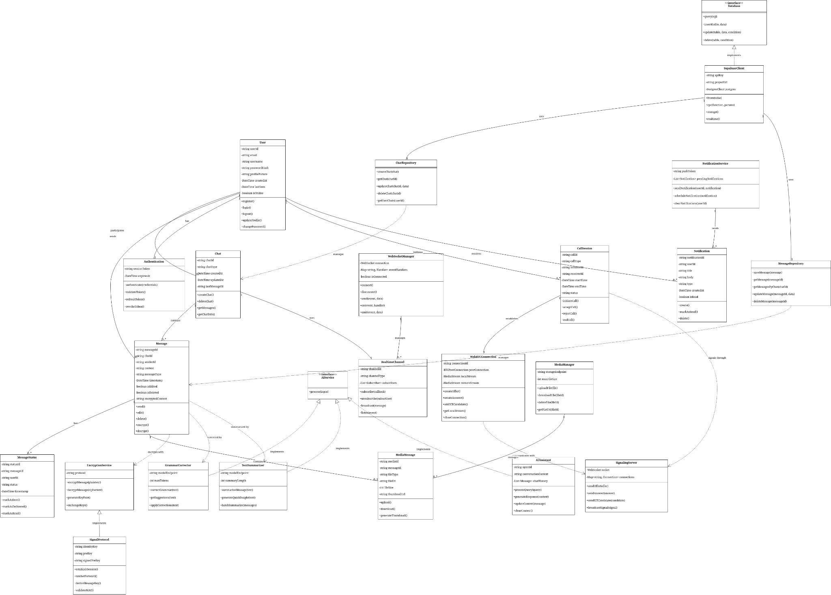https://drive.google.com/file/d/1l2aDXp_RBbo18ZSdV2ic667vYr1wSqty/view?usp=sharing

# **Use Cases 1-4 (Qatada)**

## **Use Case 1)**

### **Activity Diagram:**

### 

### **Sequence Diagram:**

### **State Machine Diagram:**

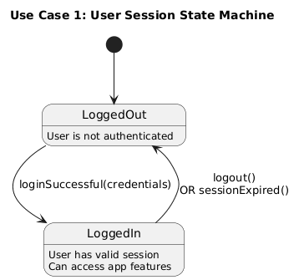

## 

## **Use Case 2)**

### **Activity Diagram:**

### 

### 

### 

### **Sequence Diagram:**

### **State Machine Diagram:**

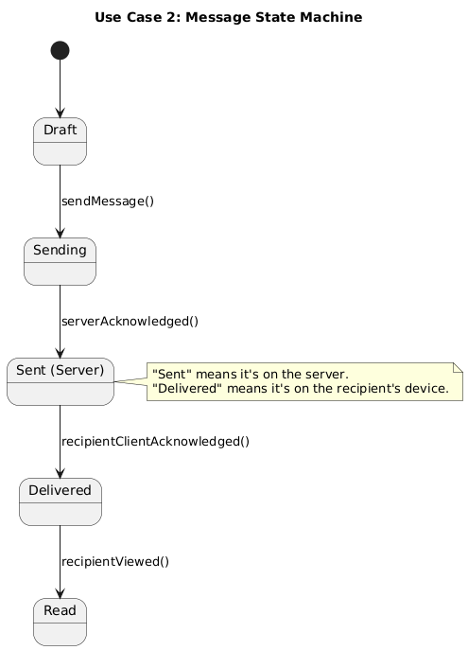

## **Use Case 3)**

### **Activity Diagram:**

### 

### 

### 

### 

### 

### **Sequence Diagram:**

### **State Machine Diagram:**

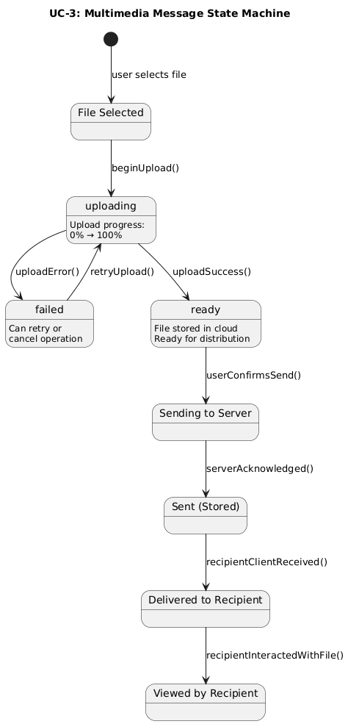

## 

## **Use Case 4)**

### **Activity Diagram:**

### 

### **Sequence Diagram:**

### 

### **State Machine Diagram:**

# **Use Cases 5-8 (Ezaan)**

## **Use Case 5)**

### **Activity Diagram:**

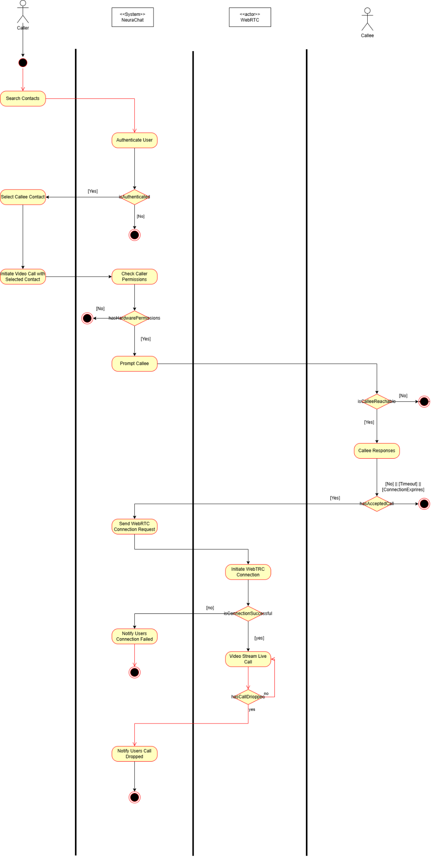

### **Sequence Diagram:**

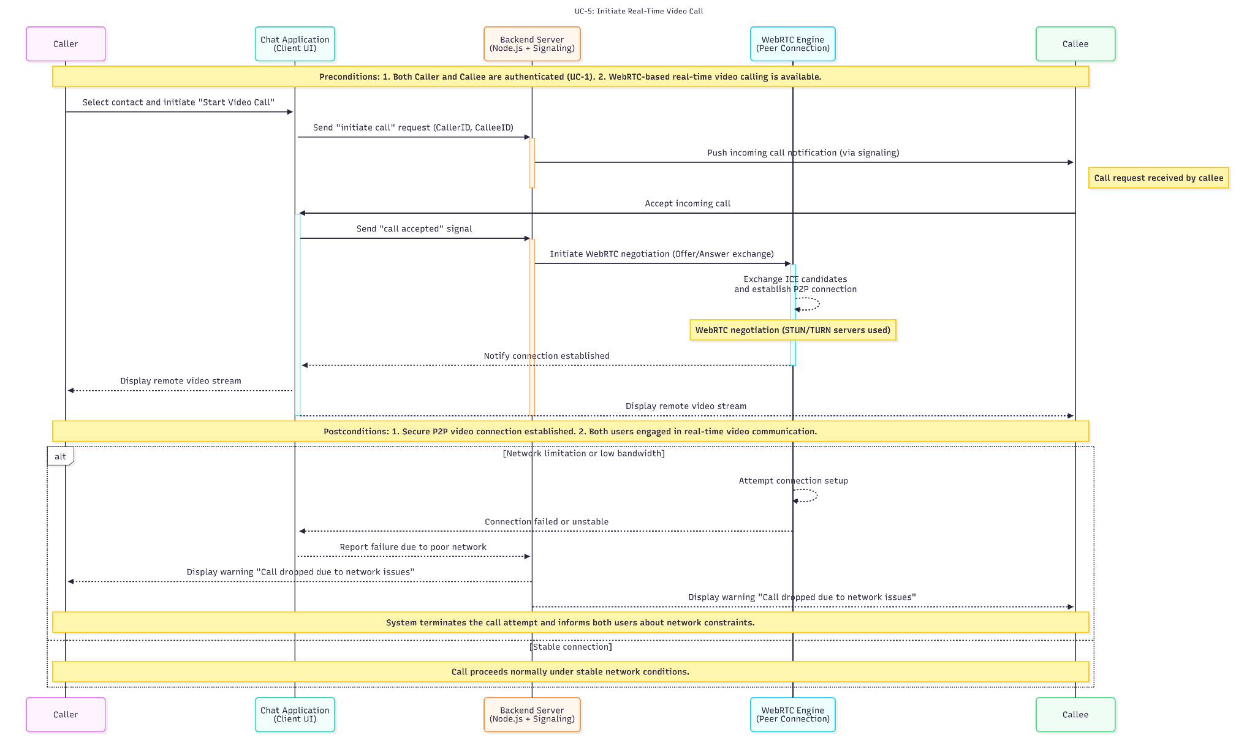

### **State Machine Diagram:**

## 

## **Use Case 6)**

### **Activity Diagram:**

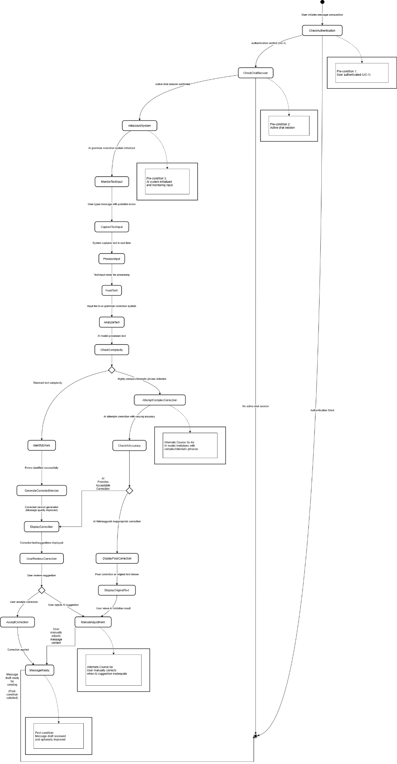

### **Sequence Diagram:**

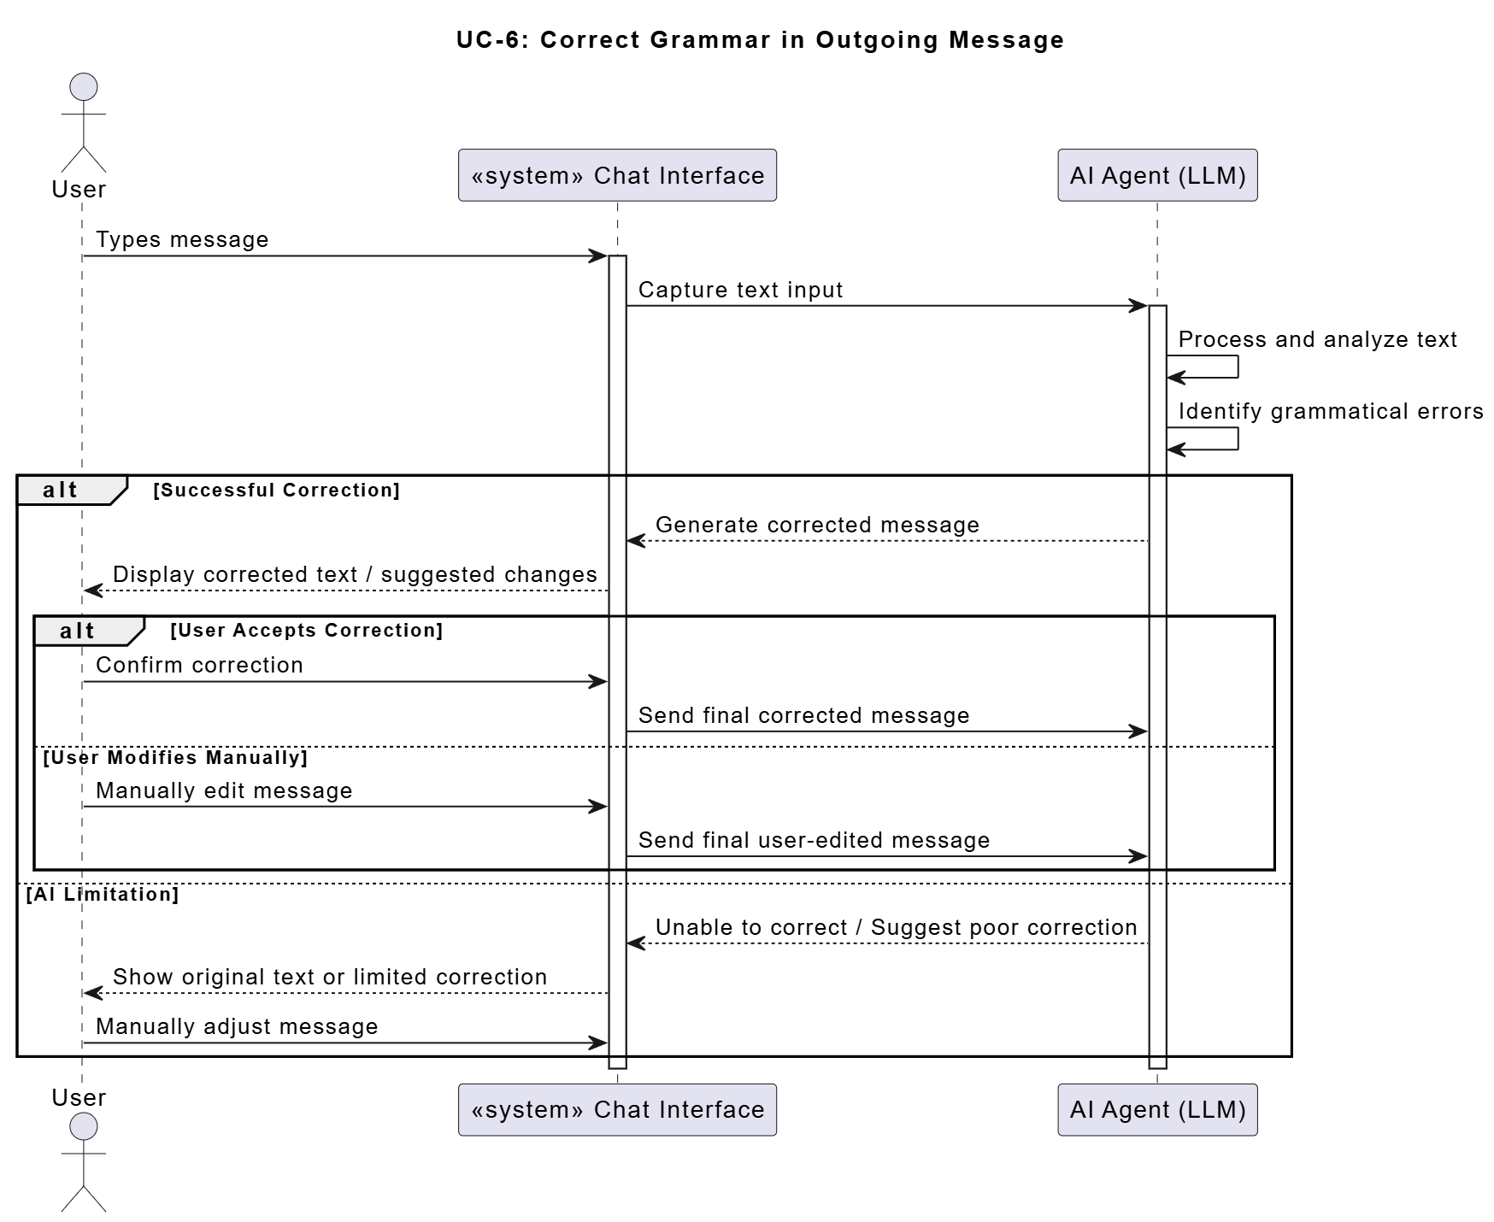

### **State Machine Diagram:**

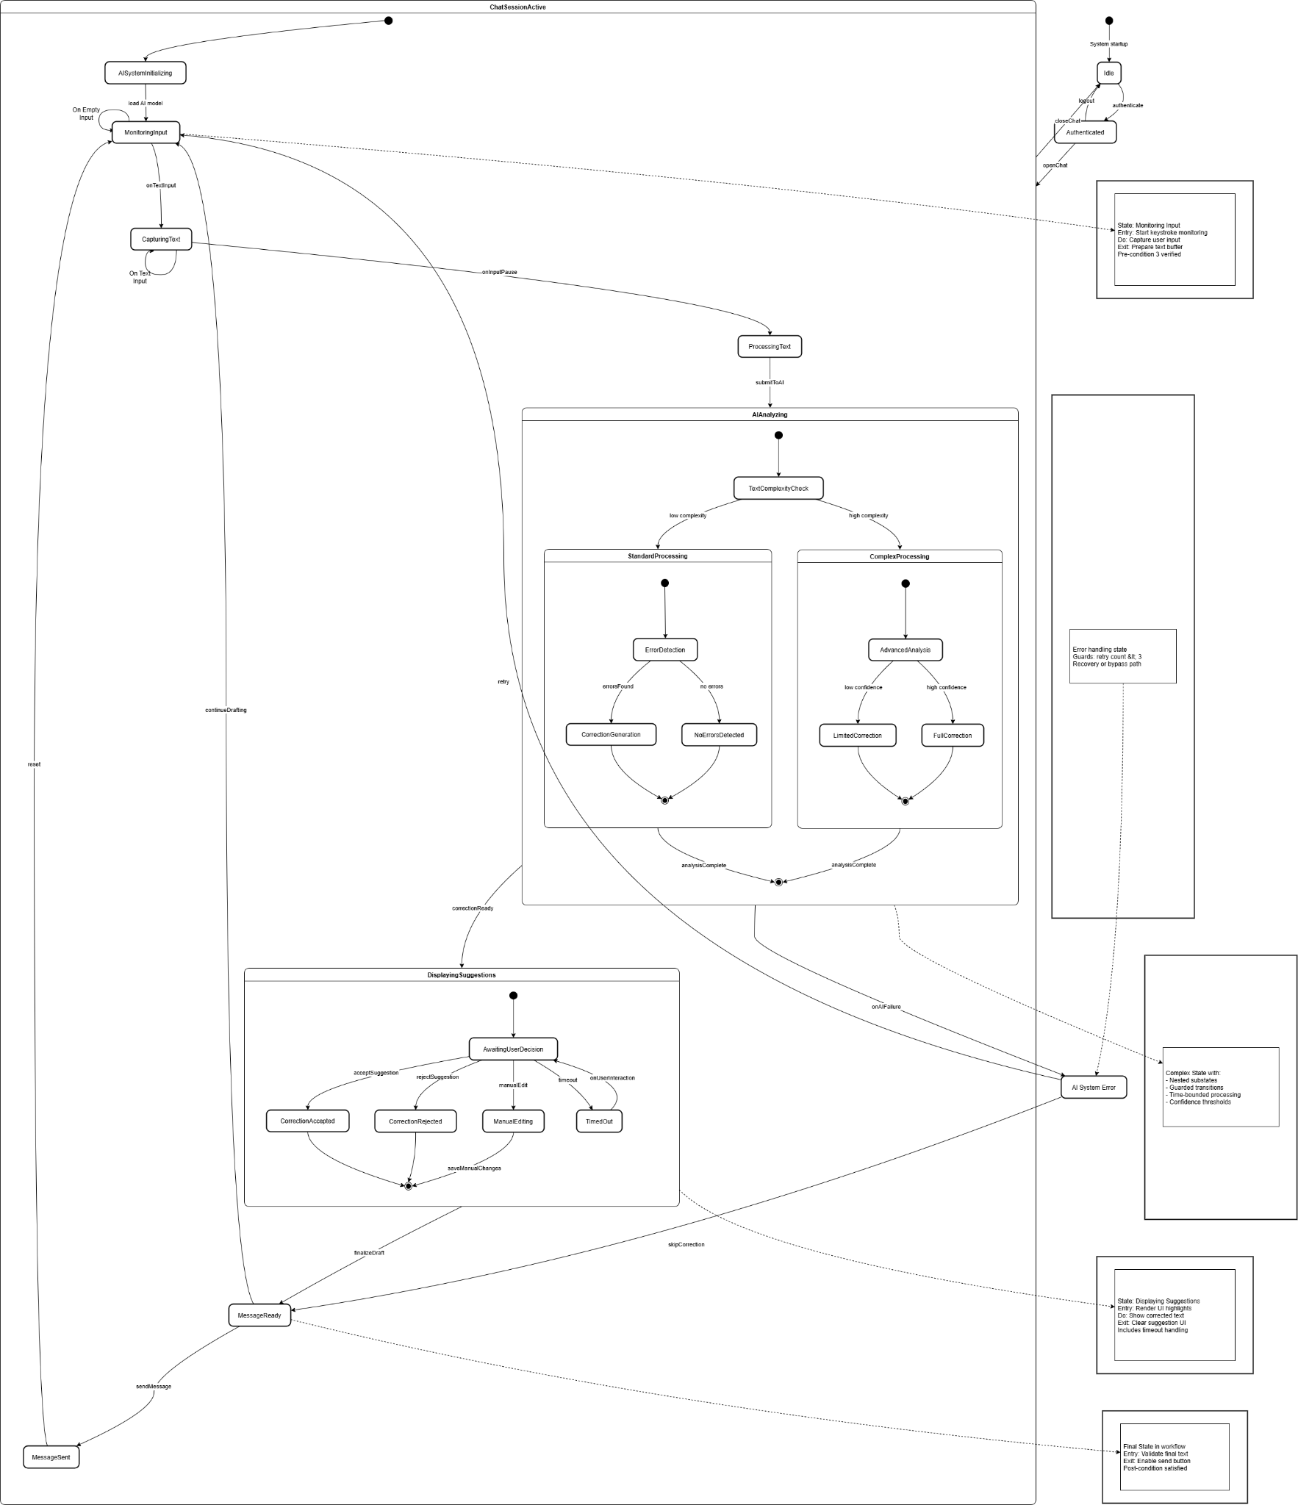

## 

## **Use Case 7)**

### **Activity Diagram:**

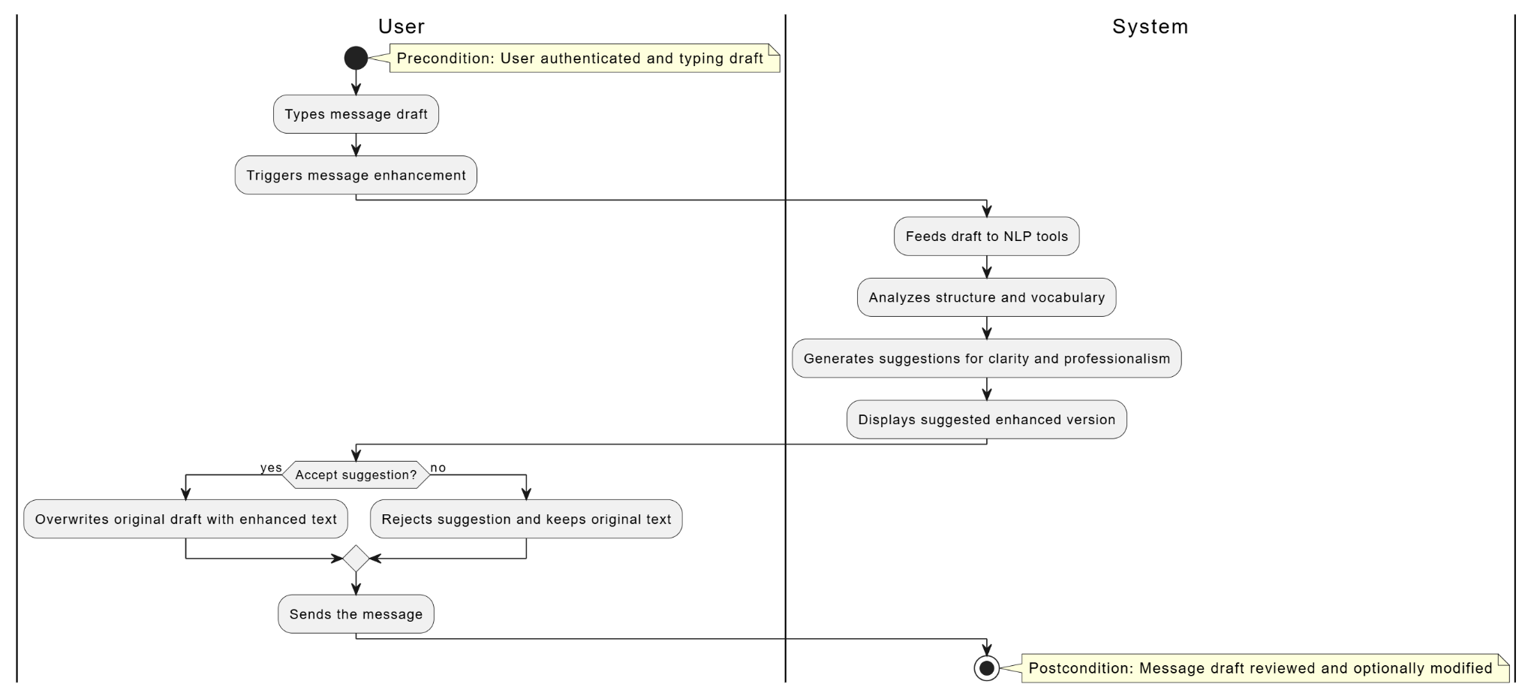

### **Sequence Diagram:**

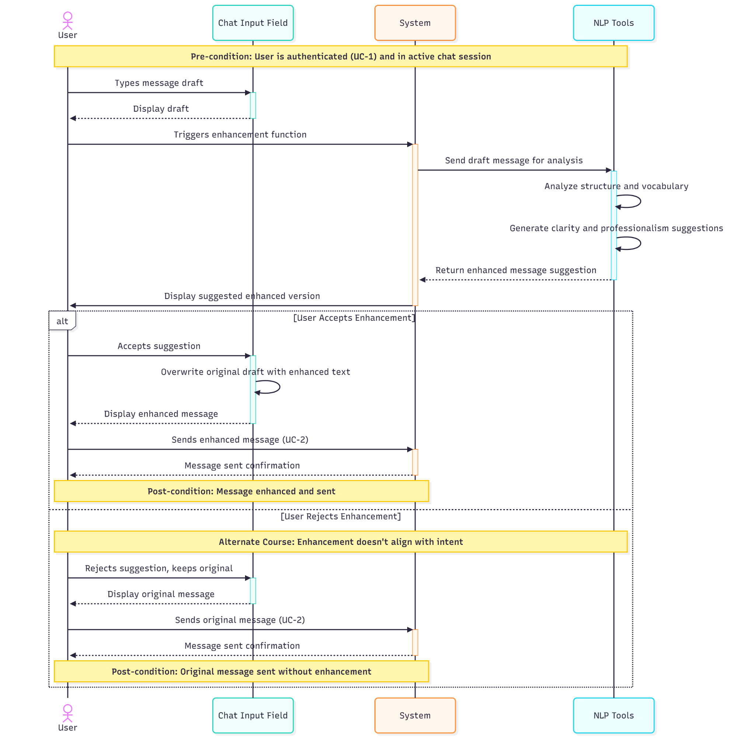

### **State Machine Diagram:**

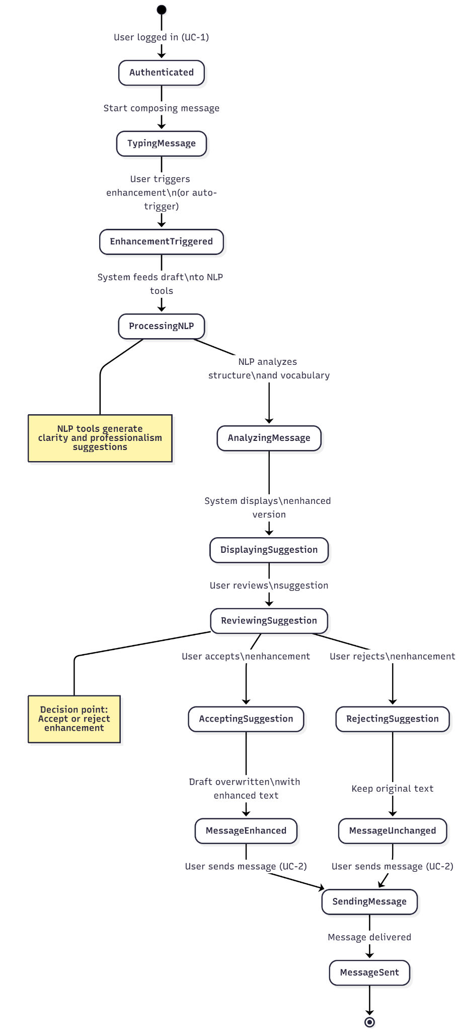

## **Use Case 8)**

### **Activity Diagram:**

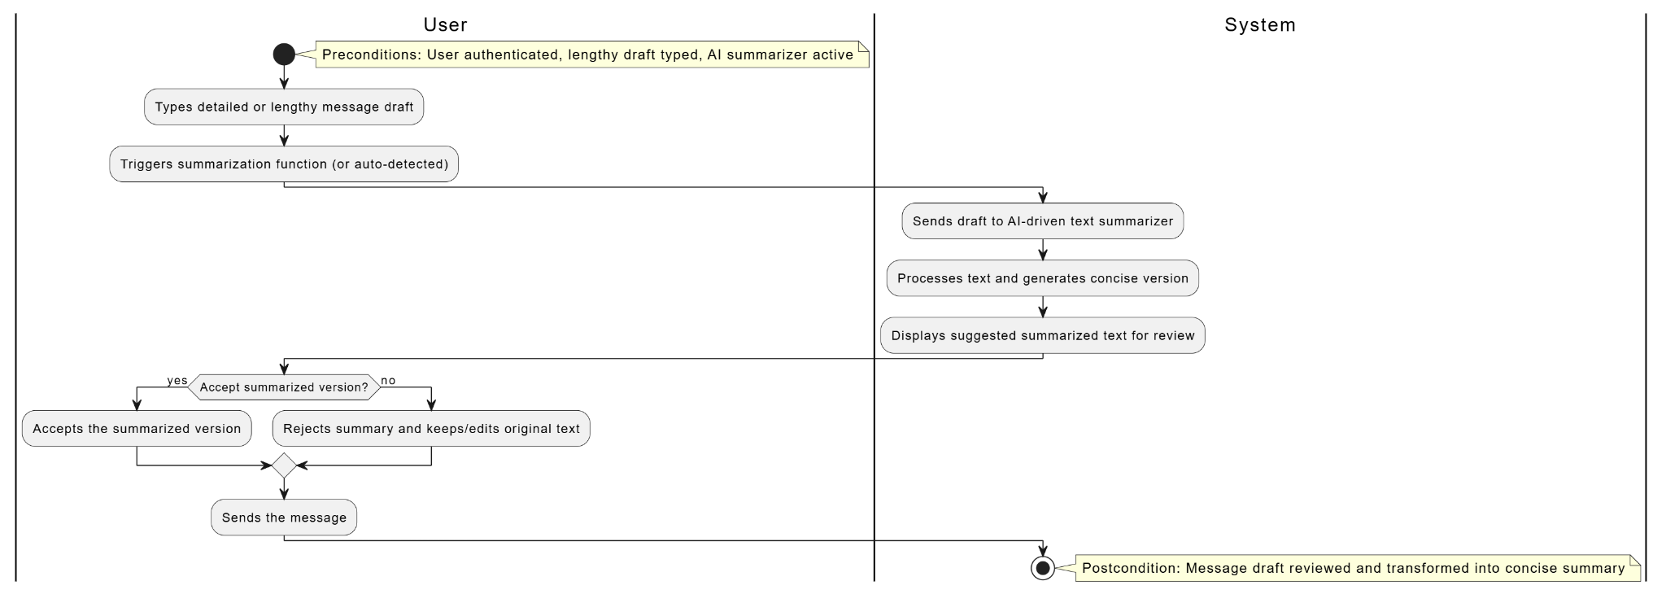

### **Sequence Diagram:**

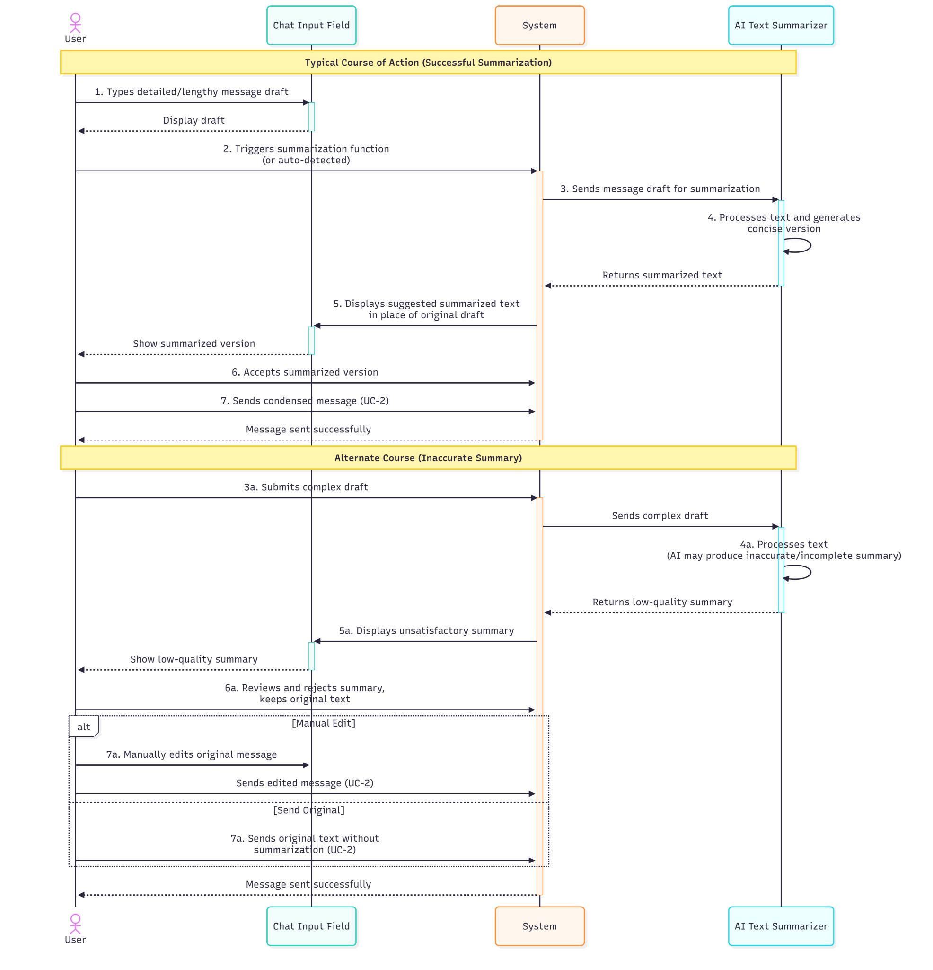

### **State Machine Diagram:**

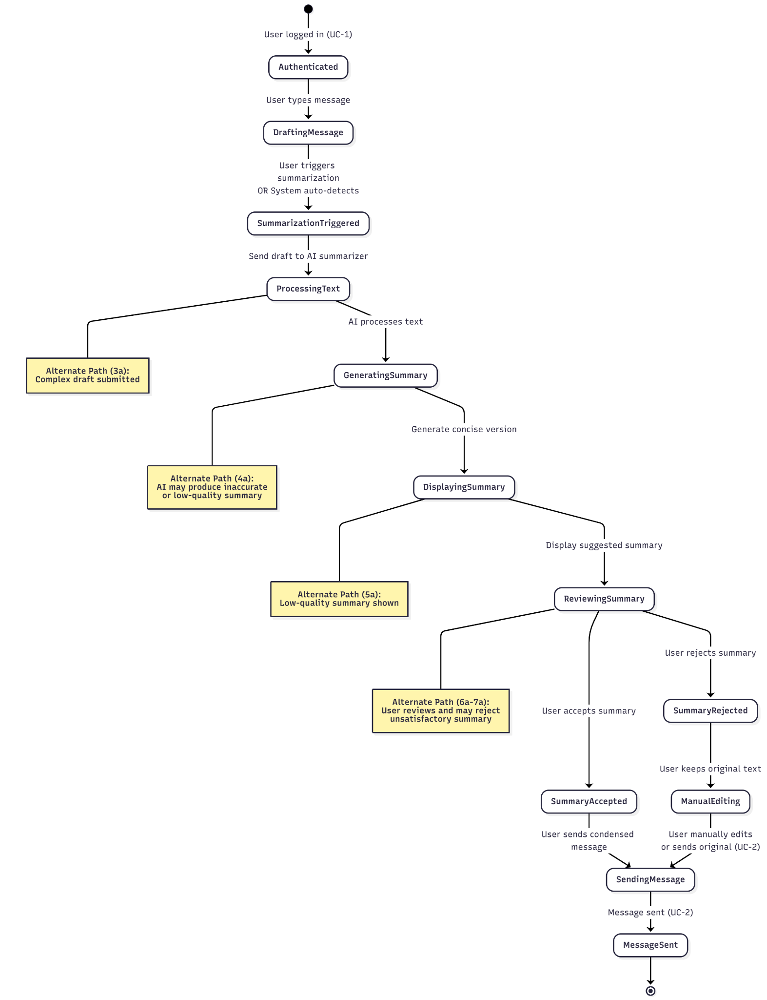

# **Use Cases 9-12 (Saad)**

## **Use Case 9)**

### **Activity Diagram:**

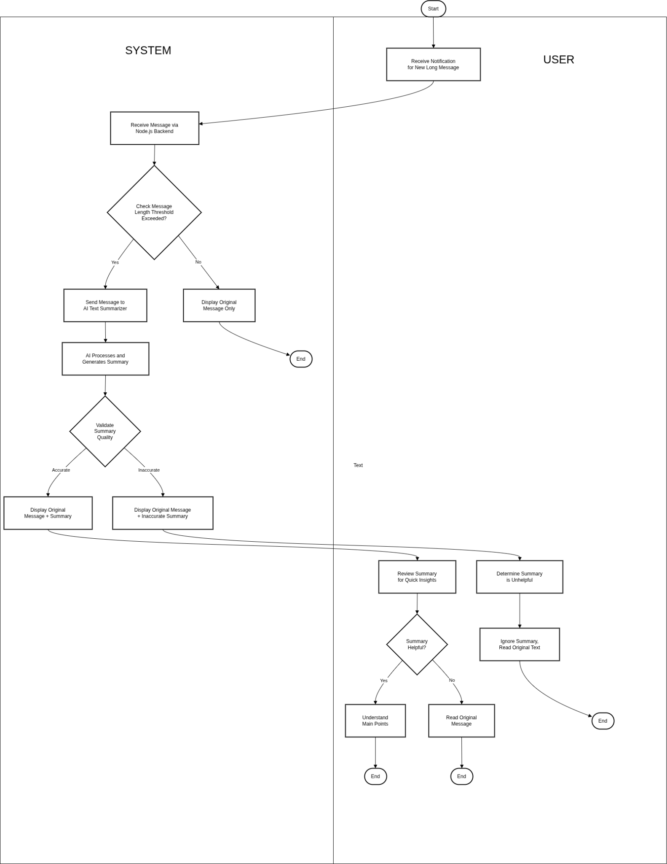

### **Sequence Diagram:**

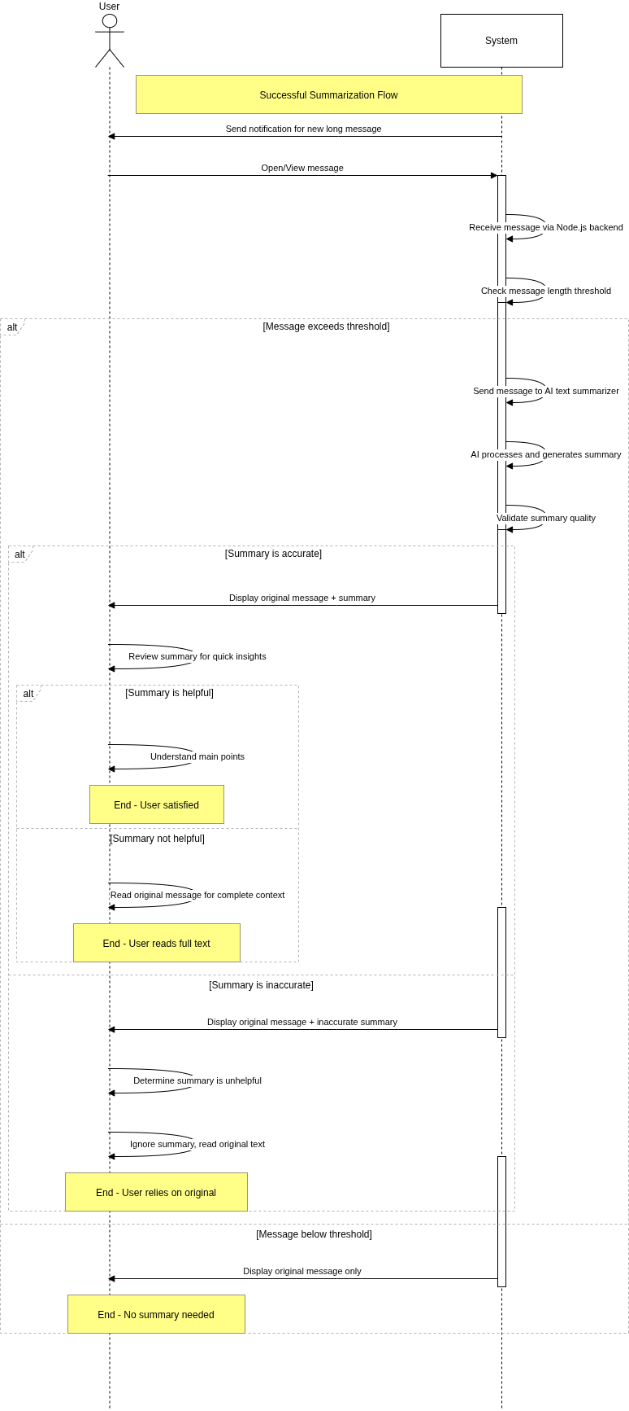

### **State Machine Diagram:**

## 

## 

## **Use Case 10)**

### **Activity Diagram:**

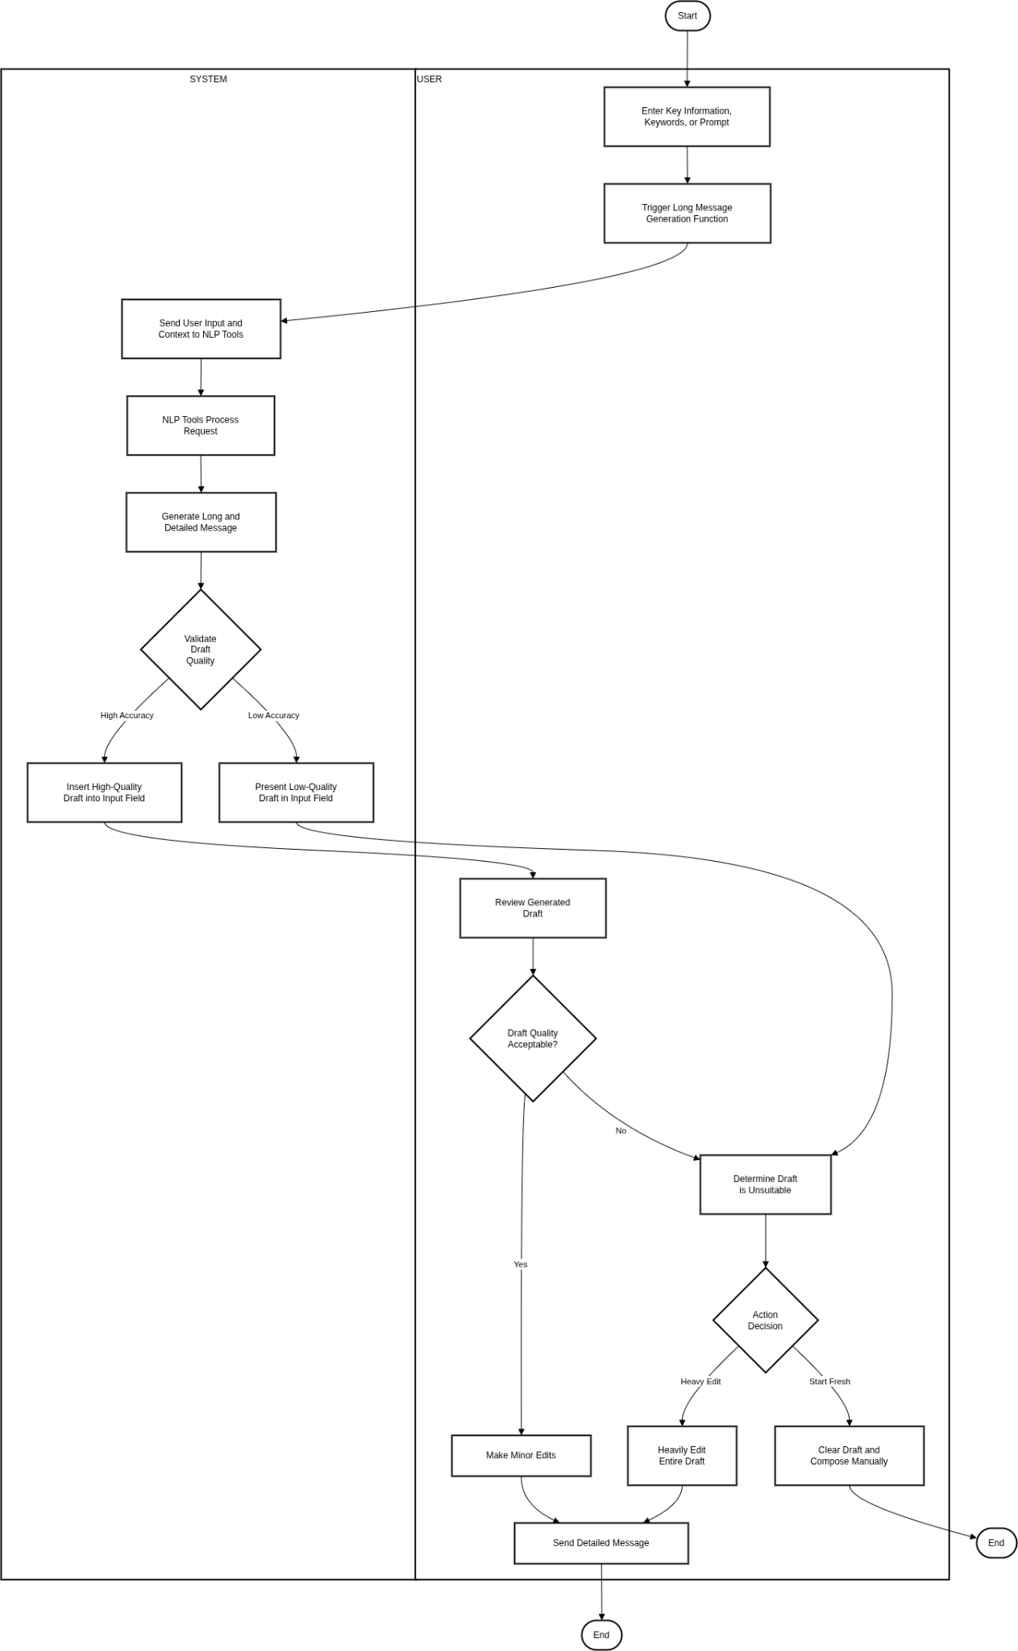

### **Sequence Diagram:**

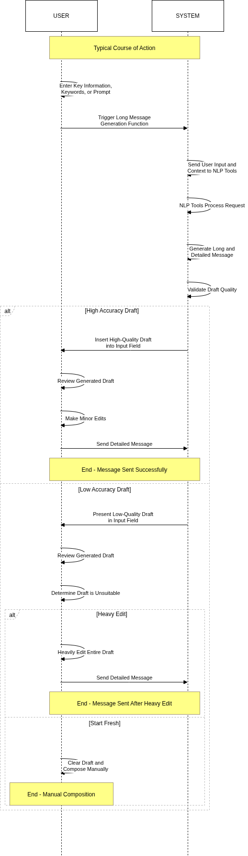

### **State Machine Diagram:**

## 

## **Use Case 11)**

### **Activity Diagram:**

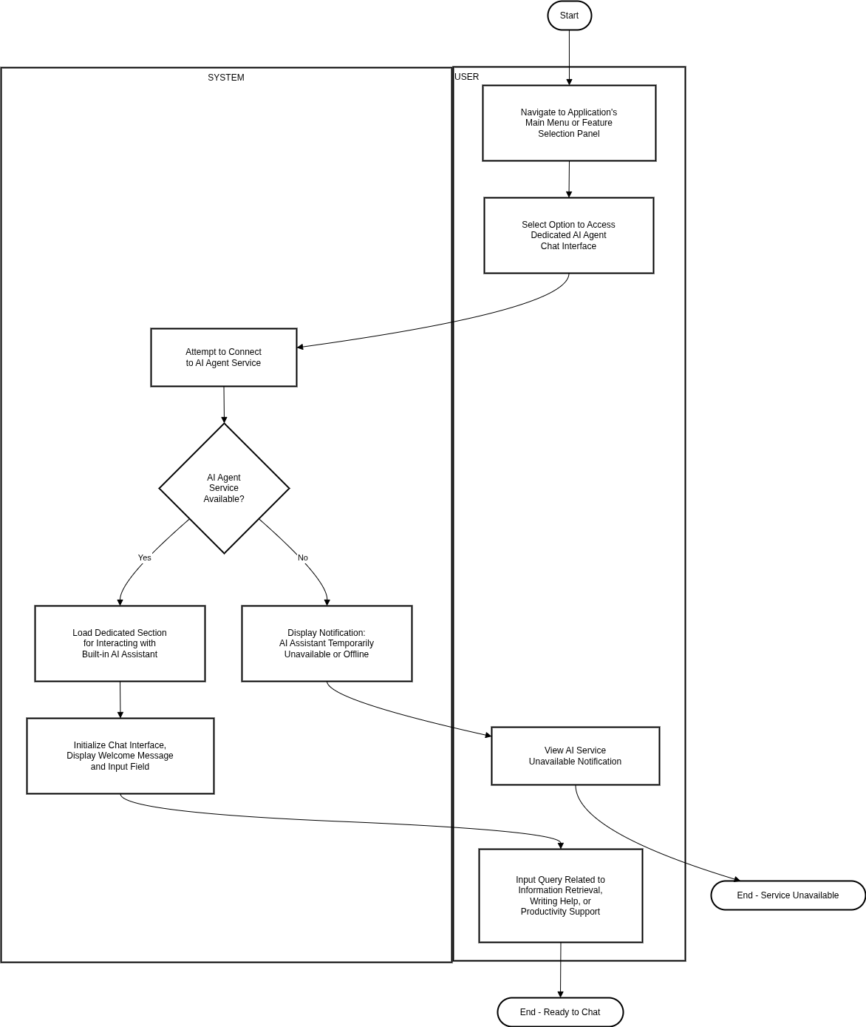

### **Sequence Diagram:**

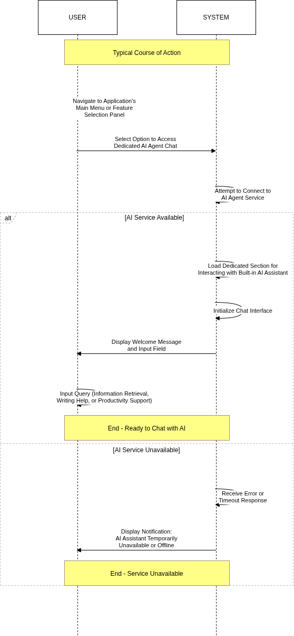

### **State Machine Diagram:**

## 

## **Use Case 12)**

### **Activity Diagram:**

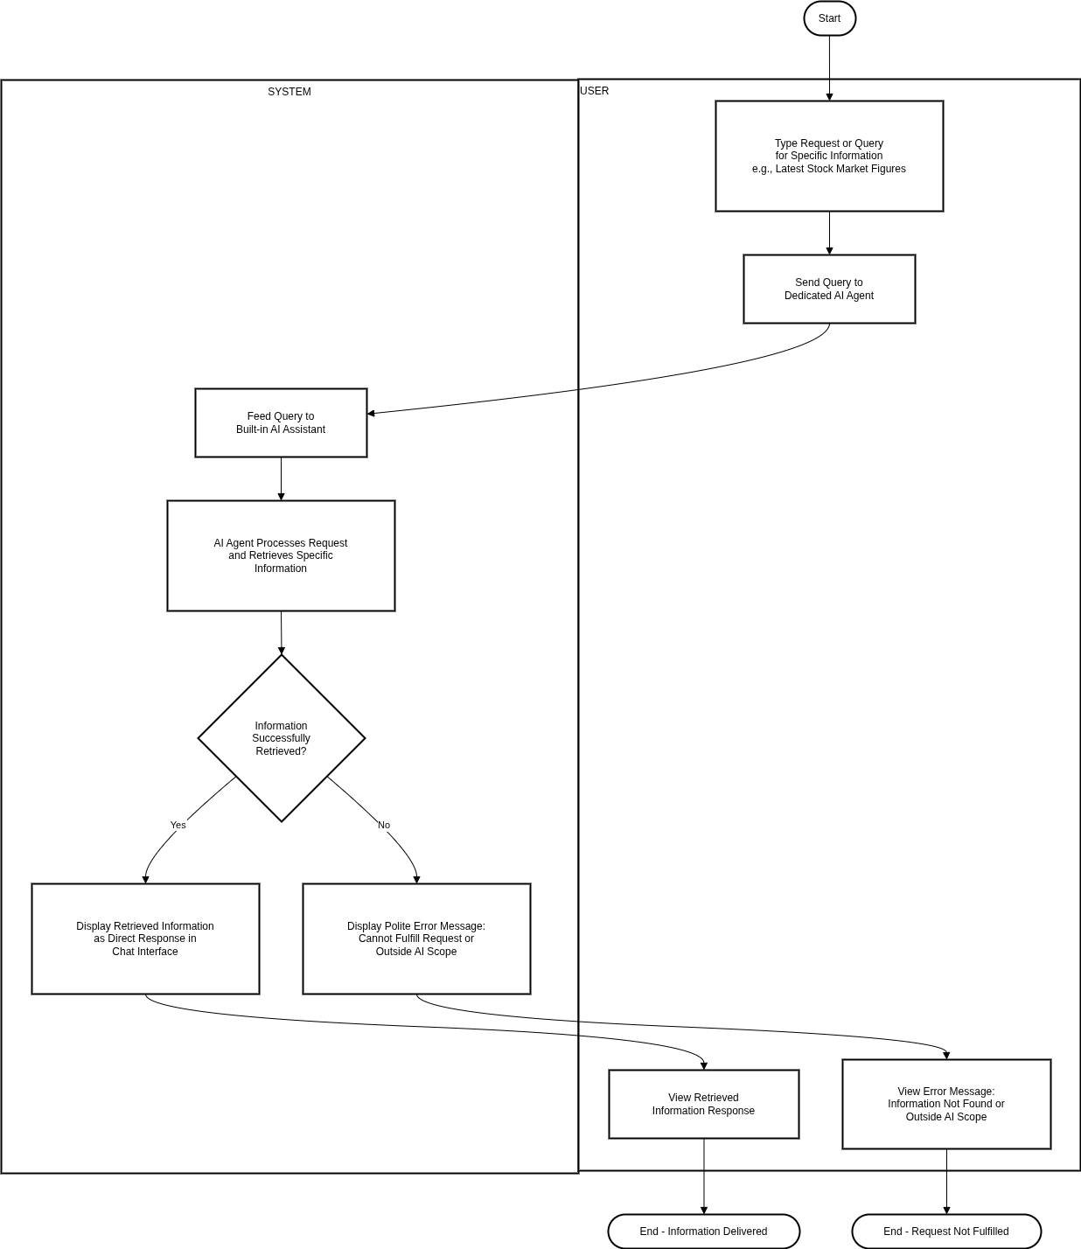

### **Sequence Diagram:**

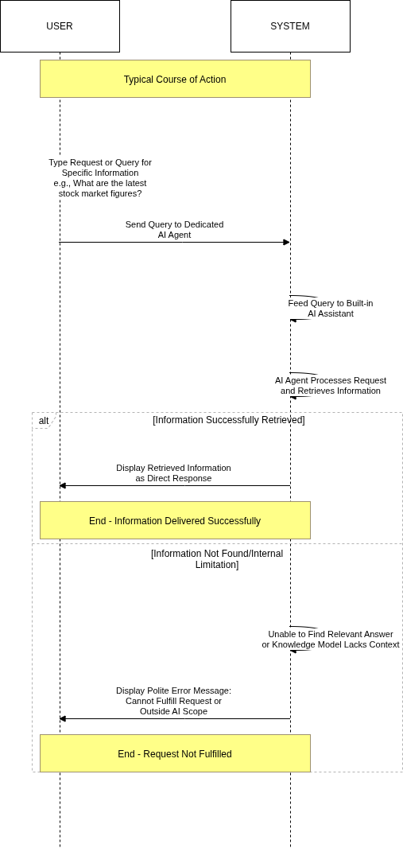

### **State Machine Diagram:**

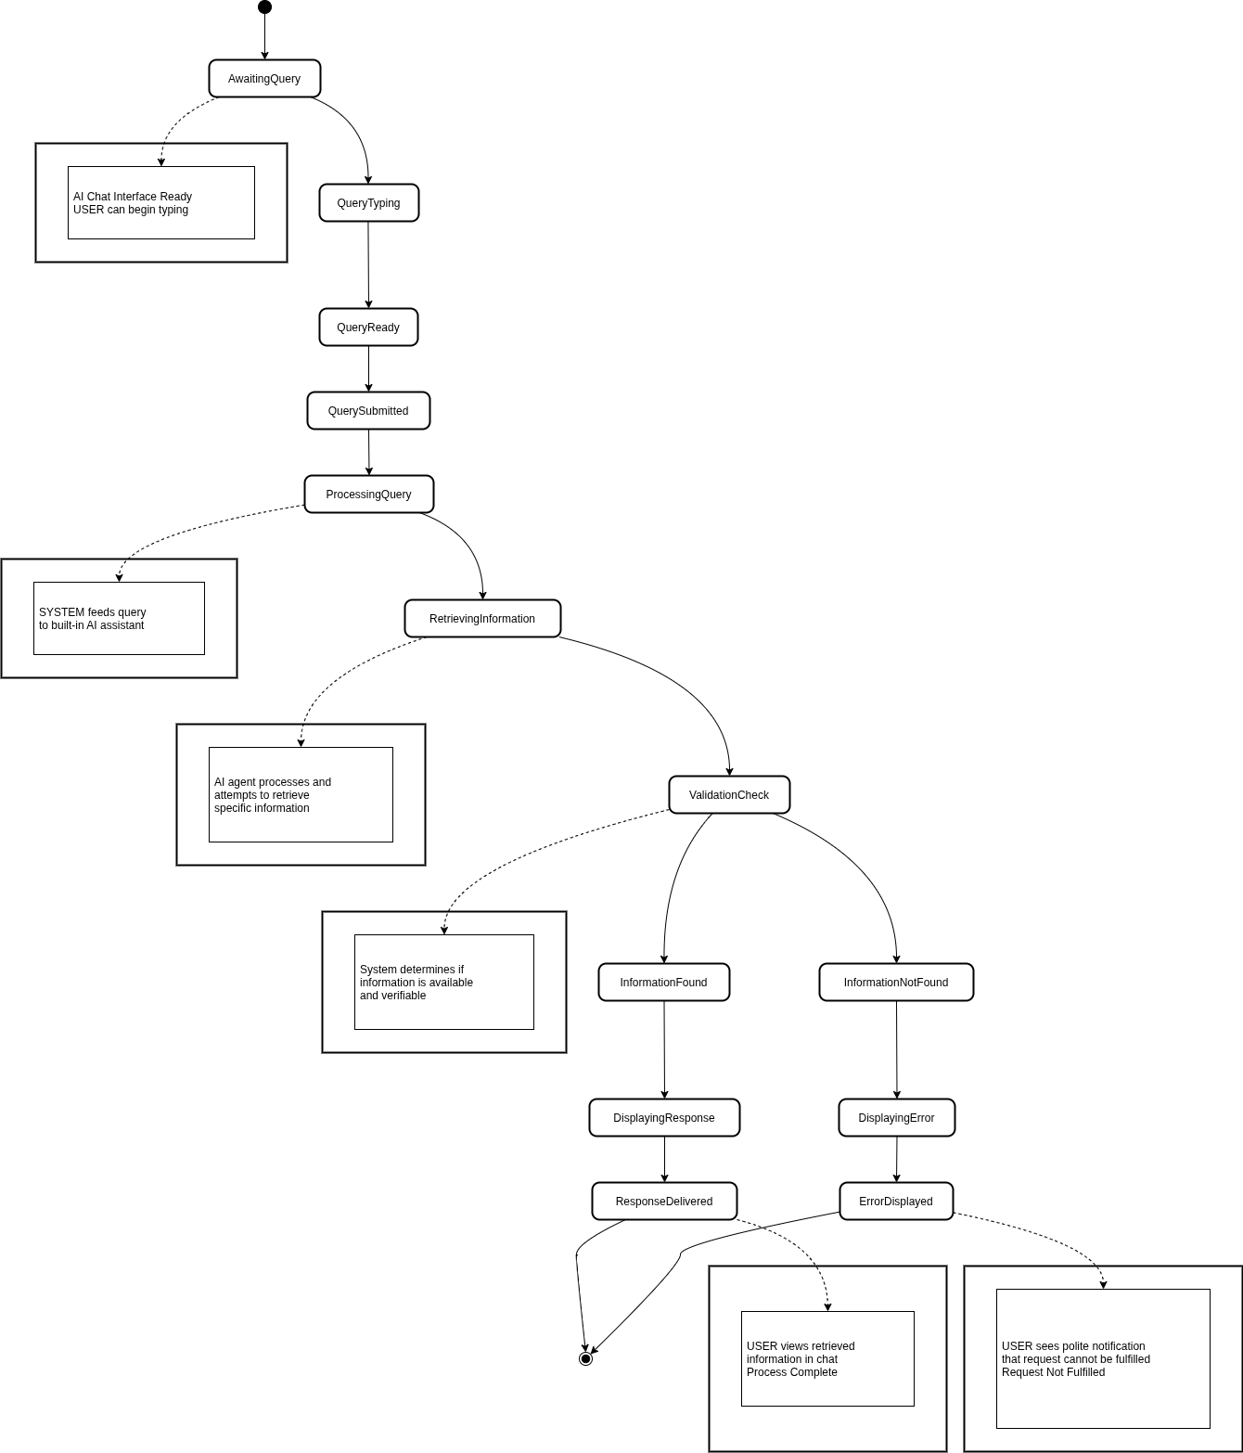

# **Use Cases 13-15 + EERD (Anees)**

## **Use Case 13)**

### **Activity Diagram:**

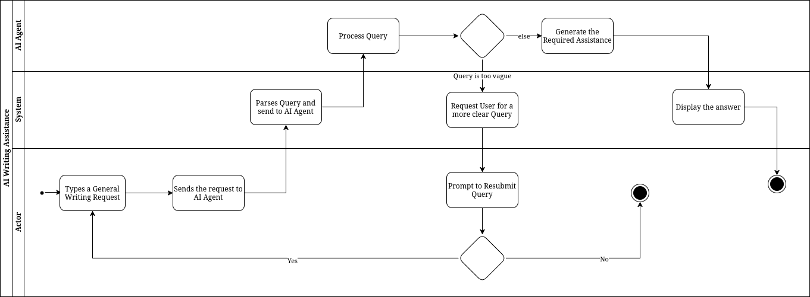

### **Sequence Diagram:**

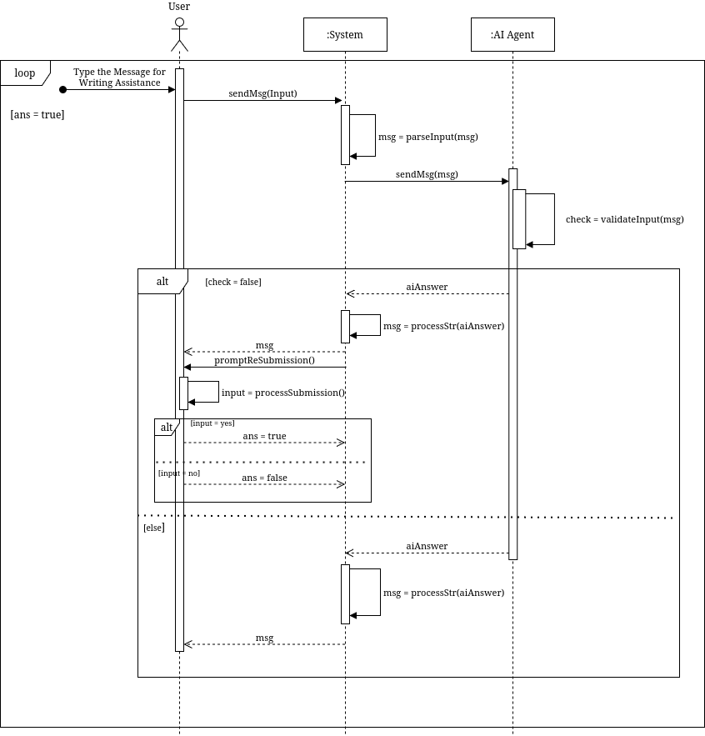

### **State Machine Diagram:**

## 

## 

## **Use Case 14)**

### **Activity Diagram:**

### **Sequence Diagram:**

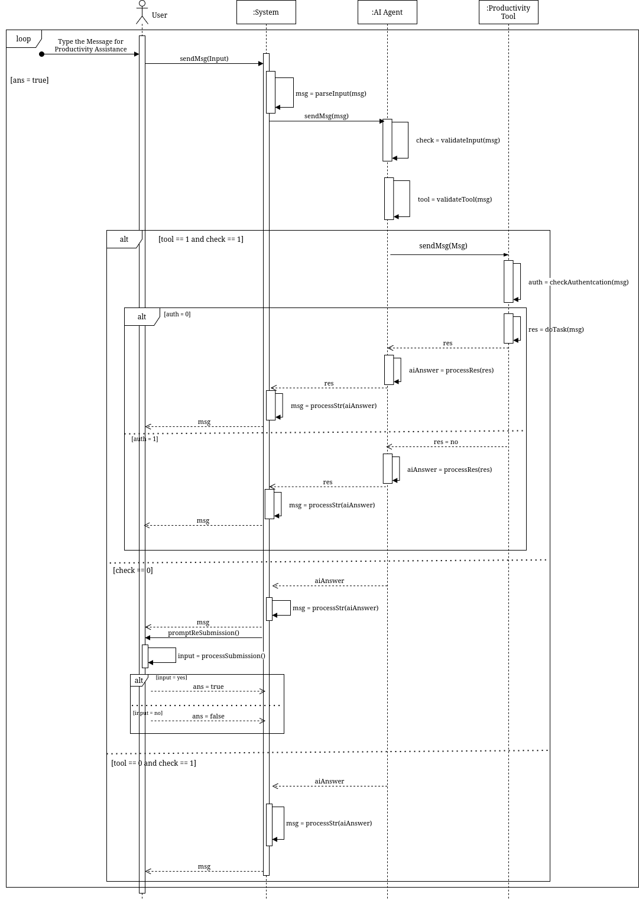

### **State Machine Diagram:**

## 

## **Use Case 15)**

### **Activity Diagram:**

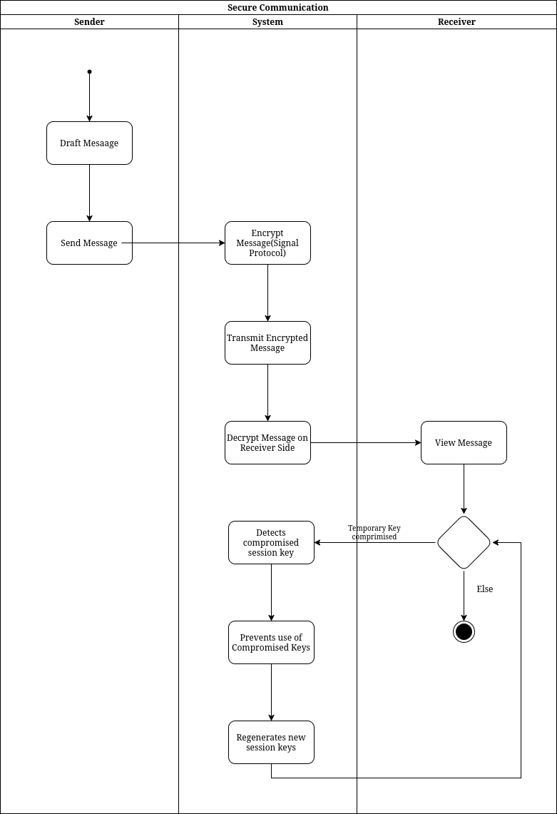

### 

### **Sequence Diagram:**

### 

### **State Machine Diagram:**

## 

## 

## 

## 

## 

## 

## 

## 

## 

## 

## 

## 

## 

## 

## **EERD)**

## 

## 